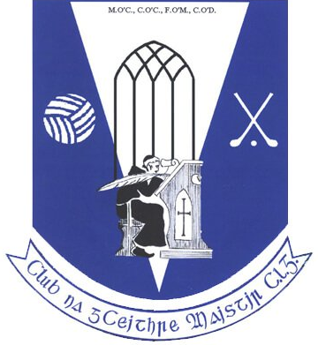
Four Masters GAA - Club Notes - 10th August 2020

Club Lotto
Peter Rooney of Peter's Manshop being presented with his recent Four Masters Lotto Jackpot win of €3,200 by Michael Masterson from the Lotto Committee. Well done Peter, a long time member of the Club Lotto, pictured here with his son Raymond and grandsons, Sam and Ben who are up and coming underage players in the club.
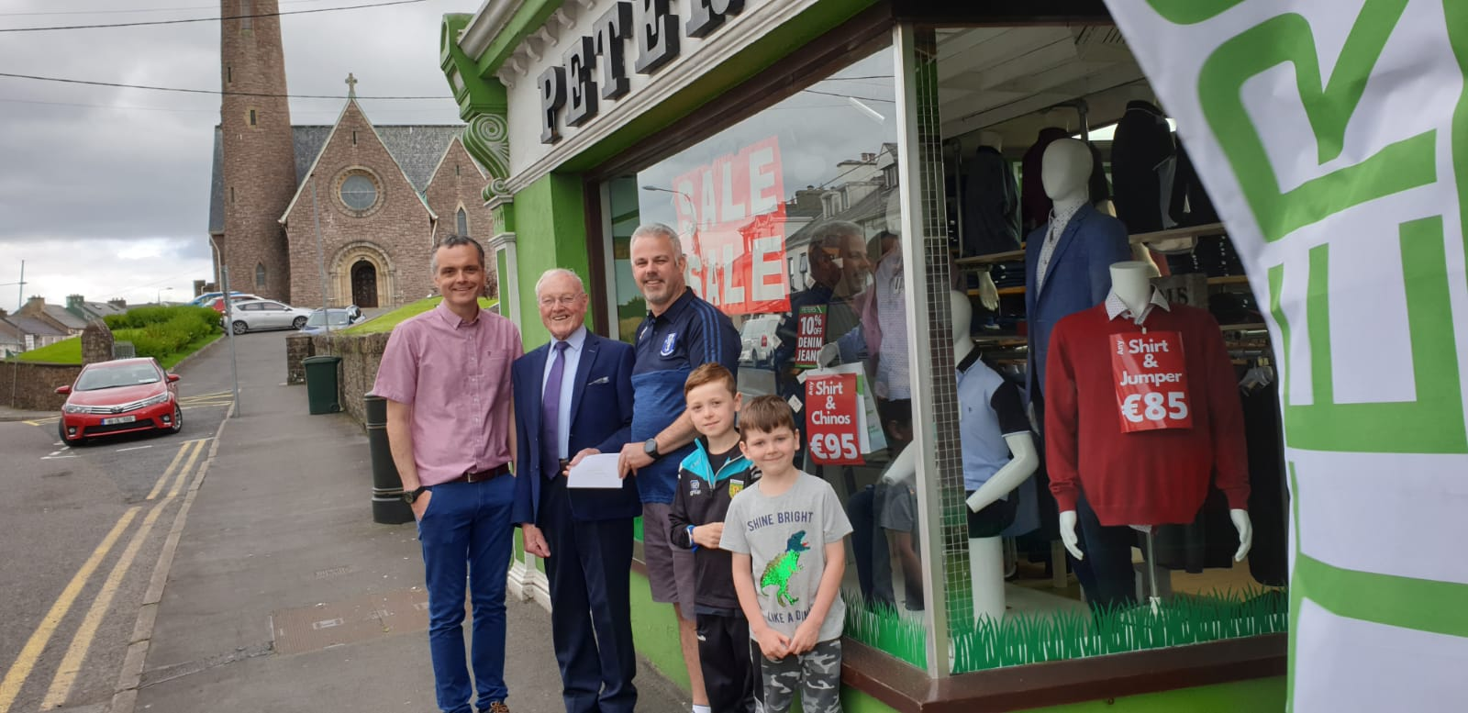
No winner of the Lotto Jackpot in the draw held on Monday 10/08/20. The winners of the €50 Doms Pier 1 Meal Vouchers are Bernie Gallagher, Clogher Barnesmore & Mary & Jim Canavan, Leghowney - Next weeks Jackpot €600. Play now at https://clubforce.com/…/gaa-four-masters-g-a-a-club-donegal/

Junior Hurling Championship – Aodh Ruadh, Ballyshannon v Four Masters 08/08/20
Aodh Ruadh, Ballyshannon – 2:18 Four Masters – 1:04
Four Masters finished second best to a strong Ballyshannon side in the Junior Hurling championship on Friday evening.
The lads played with great heart and determination throughout but they put themselves under pressure with their first touch and some wayward clearances and passing. Considering this was only their third competitive game after a long lay off, the rustiness was understandable. In contrast Ballyshannon looked like a team with plenty of recent competitive experience and the sharpness that comes with it.
Four Masters picked up a few injuries in the second half, and had a number of goal chances that they were unable to covert. Had these chances been taken, it would have put a better complexion on the scoreboard and would have been a fairer reflection of the effort and commitment of the team on the night.
Despite the scoreline, the Four Masters lads never gave up and kept battling right up to the final whistle. With the big panel of players togged out on the night and the obvious courage and determination of the players there is no doubt that better days lie ahead for this group.
Team and scorers:
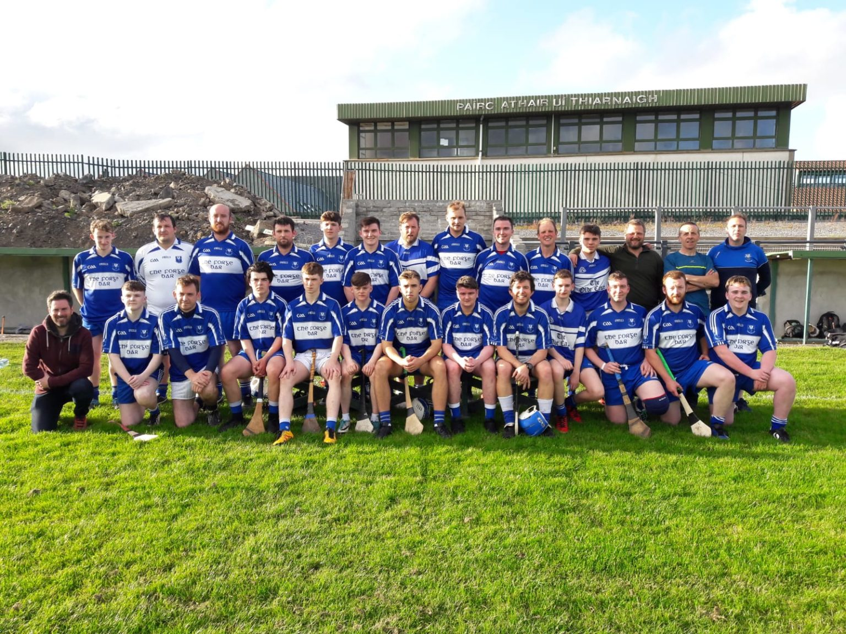
Four Masters – Shane Patton, Stephen Pearson, Shane McNulty, David Rogers, Paul Patton (0:01), Mark Patton, Eoin McCauley, Ciaran McGrory, Cathal Feeney (0:01), Phillip Myers, Jason Duignan (0:02), Cathal McGlynn, Sean Mulhern, Kieran Daly, Dylan Thomas (1:00), Shaun Campbell, Luke Sweeney, Daniel Gallagher, Ruairi O’Connor, Evan Towey, Cahir McBrearty, Shaun Conway, Martin Gillespie

Senior Football Championship – Glenswilly v Four Masters 09/08/20
Glenswilly 2 - 16, Four Masters: 1 - 13
Hard luck to the senior football team who lost out to Glenswilly in a hard fought game on Sunday evening. The lads played with a lot of heart and determination, and with a bit more luck might have edged the contest. Despite the scoreline, the team can take a lot of positives from this performance into their next game - a home tie against Dungloe next weekend.
FOUR MASTERS: Martin Cassidy; Cathal Canavan, Caolán Loughney, Brian Fagan; Daire Quinn, Dylan Kennedy, Barry Dunnion; Leo McHugh (0-1), Kevin McBrearty (0-4, 2f,1’45); Jamie Crawford (1-2), Neil Ward (0-1), Aaron McCrea (0-1); Killian Faulkner (0-3,3f), Patrick Reid, Matthew McKenna (0-1). Subs; Cian Hegarty, Cathal Feeney, Oisin Reid, Aidan McHugh, Eoin Gorrell
Next up for Four Masters is a home Championship game v Dungloe next weekend.
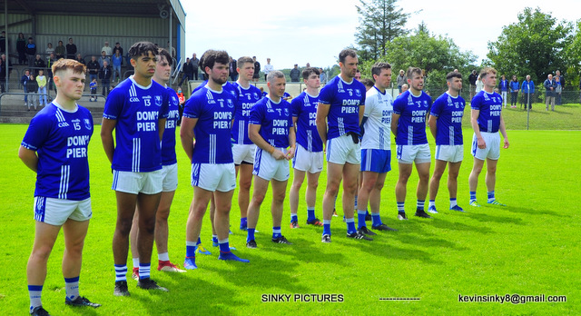
Senior Ladies Football Report
Four Masters Ladies Senior Football Squad went on the road early Sunday morning to Fanad Gaels. Despite playing attacking football from the throw-in we hit the crossbar and post 3 times, which left the half-time score in Fanad's favour, totally against the run of play. Fanad hit a purple patch in the 3rd quarter, we could have created another 5 goal chances where maybe we took the wrong option with our final pass, which is something to work on in training. Fanad, are a good side, and a side that we are on par with. The progress made and commitment shown to the Four Masters jersey since we've started is remarkable. Well done to all. Best of luck to our U14 and Minor ladies in their big games this week from all in the Senior ladies Squad.
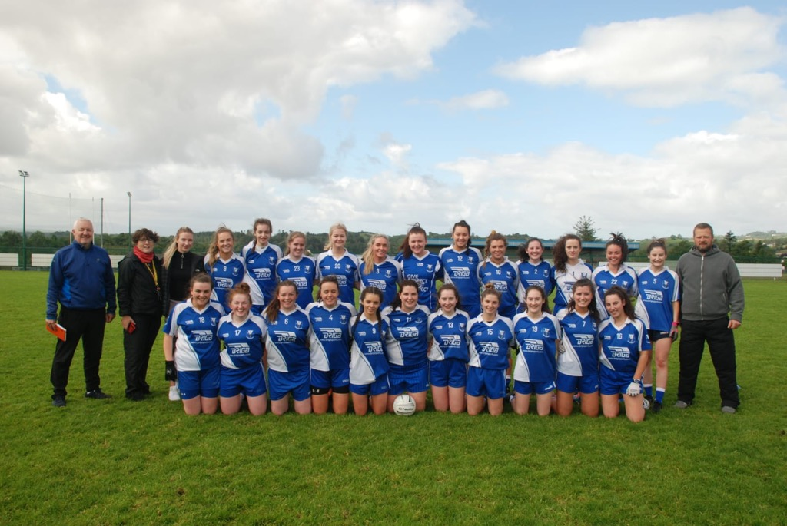

Under 14 Girls Football Report

Another fantastic performance from our U14 girls this morning in Termon. On what was a very warm day, they had to work extremely hard for their victory. We started the game strongly, with particularly good breaks out of the back line to set up scores for the hard working forwards. Teamwork and support was evident as 9 girls scored altogether, with even 2 of our half backs getting in on the scoring. Huge efforts went into the first 20 minutes of the game and this soon took its toll on our players towards the end of the first half, when we leaked a few scores but went into half time with a healthy lead of 3.9 to 3.2.
Termon started the second half stronger and soon had us pegged back to 4 points. Following a wonderful save and clearance from our brilliant young goalkeeper, the girls sprinted up the pitch and scored a goal of our own. This settled us back into playing our own passing & support game and with wave after wave of attack, we scored some fabulous points and 2 more goals, leaving us comfortable in the last few minutes.
We ran out 6.14 to 4.5 winners and were deserving of our victory, with every girl leaving the pitch exhausted.
Well done to these young ladies and best of luck in U14 final next Saturday morning.

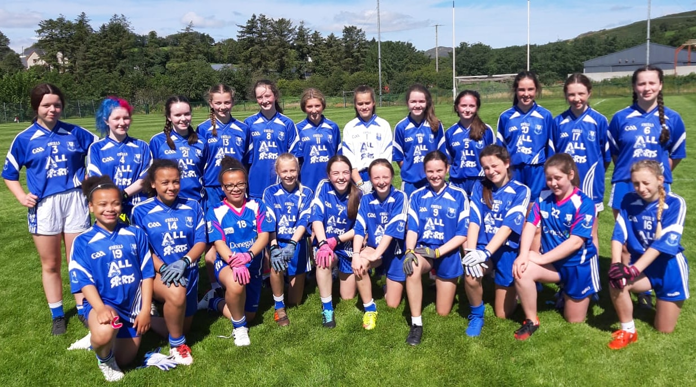

Win Your House in Dublin
Four Masters would like to encourage our club community to support the county board fund raising event in aid of the Centre of Excellence development in Convoy.
In addition to supporting the county project, each ticket sold by the club will generate a commission of €20 for the Four Masters Club itself.
Purchase a hard copy ticket now from Sean Dunnion, Paul Timoney, Barry Monaghan, Damien Dunnion or Pauric Harvey and you will earn your Club a €20.00 commission on each sale.
https://winyourhouseindublin.com/

Home fixtures confirmed for this week:
Tuesday 11th @ 6.15 PM
U14 boys B v Kilcar
Wed 12th @ 6.15 PM
U16 girls challenge match
Saturday 15th @ 11 am
U12 boys A v Ballyshannon
Saturday 15th @ 2PM
Senior men v Dungloe
Good luck to all teams.

